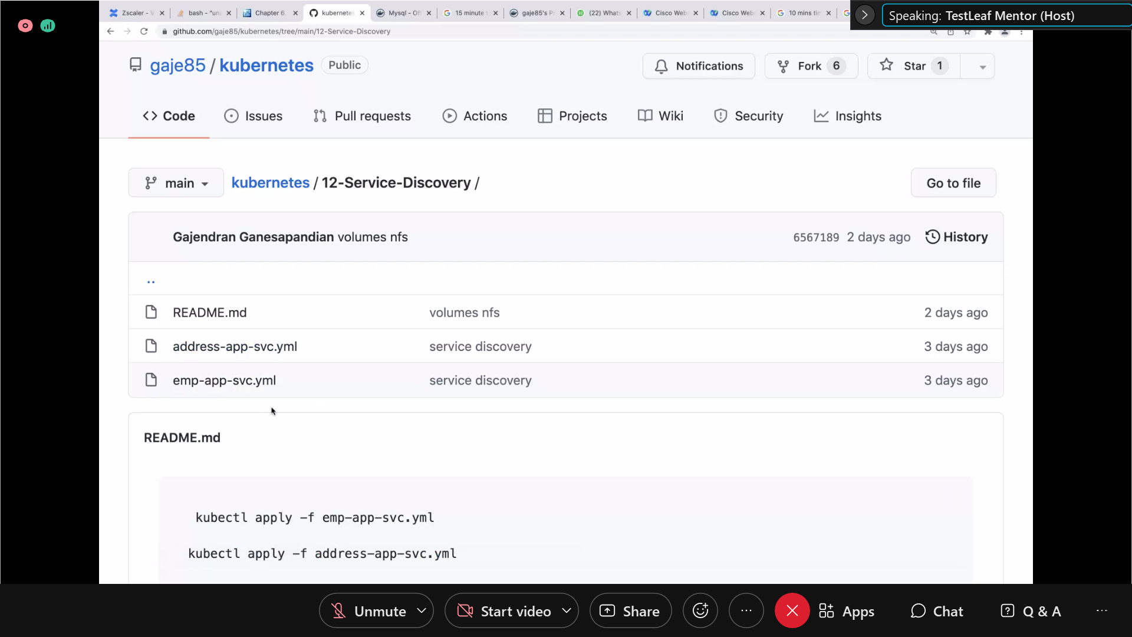

App name and kub service name should be same

Run address service

Run emp service

See log of pod

In the log of emp we can see the address

Service discovery if not using kubernetees – use euraka server(registry server)

-----

DB wont run in Kubernetes, it will run outside of Kubernetes